**Form Code Generator**

The Form Code Generator is a utility written in PowerShell to generate custom GUI utilities using the System.Windows.Forms .Net Form Controls.

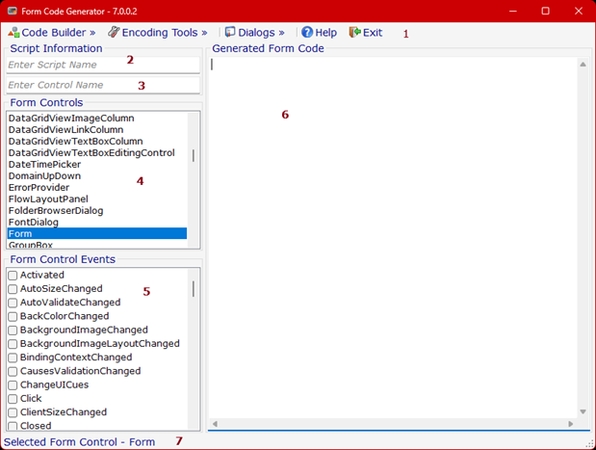

**The Form Code Generator GUI**

1. **Main Menu:** The Main Menu is where you will find the options to generate the code to create form controls, encode images and files, and view the dialog windows.
2. **Script Name:** This is the name of the script that is used as the prefix of the variable names for the generated form controls. This should be a short name or a TLA that is used to uniquely name the form controls.  
     
   The Script Name is required to generate all form controls.  
     
   The Form Code Generator uses FCG as the Script Name.  
     
   **Example:** $FCGForm is the Name of the Variable for the primary form control.
3. **Control Name:** This is the name to appended to the Script Name prefix to uniquely name the form control variables for controls that are the same type.  
     
   The Control Name is required to generate all from controls, except for the form control, all dialogs, and the functions Library.  
     
   **Example:** $FCGScriptNameTextBox is the name of the Script Name TextBox
4. **Form Controls:** This is the list of the System.Windows.Forms .Net Form Controls that you can use to build the GUI utility.
5. **Form Control Events:** These are the list of Events that are supported by the selected form control.
6. **Generate Form Code:** This is the TextBox where the generated code will be displayed for you to copy.
7. **Status Messages:** This see where you will see the status of the options you select from the Main Menu.

**Keyboard Commands**

The Form Code Generator supports the following keyboard commands.

**Commands**

* **F2:** Opens the Change Log dialog window.
* **Ctrl-Alt-F10:** Opens the Debugging console window.
* **ESC:** The Escape key will close all the dialog windows.

**Debugging Console Window**

When the Debugging console window is opened verbose logging will be enabled and will display a message in the console window when any of the form events or script functions are executed.

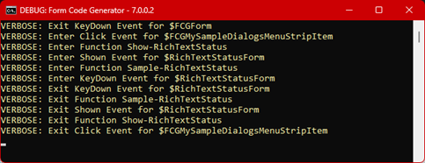

**Code Builder Menu**

The Code Builder Menu has options to generate PowerShell code for form controls and events, custom dialogs, the script functions library, and the source code for the Form Code Generator.

**Form SubMenu Options**

The Form submenu has options to generate the from control with either a panel or splitcontainer and all supporting code for a GUI utility.

These menu options will generate a fully functional basic GUI script.

Selecting the Form control in the Forms Control list is not required before generating the form control / script using these options.

The Supporting Code consists of the following

* The MyConfig class for common utility configuration options.
* The MyRuntime class for the configuration options that are set during runtime.
* Code Library
* Common dialogs
* The GUI Form code with a panel/splitcontainer
* Main Menu and Status bars
* Common event functions for all controls
* Other miscellaneous supporting code

**Generate Menu Option**

The Generate option will generate the code for the select control in the Forms Control list and any checked events in the Form Control Events list.

If the form control is selected this will also generate the same code as the Form submenu options except it will not include a panel or splitcontainer control.

**Control Menu Option**

The Control menu option will generate just the code for the selected from control from the Form Controls list.

**Event Menu Option**

The Event menu option will just generate the checked events in the Form Control Events list.

**Dialogs**

Dialogs are covered under the Dialogs help topic

**Library**

The Library menu option copies the Code Library, that is included when you generate a form control, into the Generated Form Code TextBox for you to copy.

**Code Library**

* Sample Enumerations
* Sample Classes
* Windows APIs
* Functions Library
* Runspace Pool functions
* Runspace Pool Code Example
* Start-Jobs Code Example

**Source Code**

The Source Code menu option copies the Form Code Generator code into the Generated Form Code TextBox for you to copy.

**Encoding Tools**

The Encoding Tools Menu has options to encode images and files so they may be included in the generated form script.

**Encoding Image**

The Encoding Image menu option lets you select and convert an image to Base64 code to include in the generated script.

Will also add an example of how to use the encoded image in your script.

**Support File Types**

* **ICO (Icon File):** Includes a line of code and adds the icon to the ImageList
* **GIF (Image):** Retains the Gif automation which allows you to have an automation displayed on the GUI form. When processing a loop you need to add the command [System.Windows.Forms.Application]::DoEvents() in the loop in order to display / update the GIF automation
* **All Others:** All other supported image types (*.bmp, *.jpg, *.jpeg, and *.png) will be converted into a Jpeg and will remove any saved meta data.

**Encode File**

The Encode File menu option converts a file to Base64 and includes example code on how to convert the encoded file back to text or binary (*.exe) file.

**Compress Text**

Compresses Selected Text file using Zip Compression

Best option for generating Rtf Documents for the Show-Information dialog

**Extract Icon**

The Extract Icon menu options lets you open and browse the icons that are included in a *.dll, *.exe, or other file type and coverts the selected icons 16x16 and 32x32 sizes to Base64.

**Windows Icon Library DLLs**

* %systemroot%\system32\imageres.dll
* %systemroot%\system32\shell32.dll
* %systemroot%\system32\ddores.dll
* %systemroot%\system32\pifmgr.dll
* %systemroot%\system32\accessibilitycpl.dll
* %systemroot%\system32\moricons.dll
* %systemroot%\system32\mmcndmgr.dll
* %systemroot%\system32\mmres.dll
* %systemroot%\system32\netcenter.dll
* %systemroot%\system32\netshell.dll
* %systemroot%\system32\networkexplorer.dll

**Dialogs**

There are 2 Dialogs menus, one under the Code Builder menu and the other on the Main Menu toolbar.

**Dialogs Menus**

* **Code Builder:** The Dialogs submenu commands under the Code Builder menu will copy the function to the Generated Form Code TextBox.
* **Main Menu:** The Dialogs submenu commands on the Main Menu open examples of the all the dialogs included in the Form Code Generator.

One of each of the dialogs listed below will be included in the generated script when generating a form control.

When selecting one of the example dialog menu options the value the dialog returns will be displayed in the Generated Form Code TextBox.

**Templates**

The Basic and Advanced and templates are starter function templates to create your own custom dialogs.

* **Basic:** The Basic Templates lets you set any value for the dialog button names.
* **Advanced:** The Advanced templates require you to use the the DialogResult values as the dialog button names. (i.e. Abort, Cancel, Ignore, No, None, OK, Retry, and Yes)

**Show RichText Status**

The Show RichText Status dialog allows you to display the status / progress of an action to the user while is it being executed.

This dialog has options to pause processing, break out of the processing loop, and auto close when there is no error.

**Show ProgressBar Status**

The Show ProgressBar Status dialog displays the process when processing a list of objects.

This dialog has options to pause processing and break out of the processing loop.

**Show Change Log**

The Show Change Log displays the change log located in the block comments at the top of the generated form code script.

By default pressing F2 will display the change log for the generated form utility.

**Change Log**

The Show Change Log will display the change log of the generated script from the first block comments that is located at the top of the generated script.

**Show Alert Message**

The Show Alert Message dialog will display an Information, Success, Warning, or an Error alert message.

**Get User Response**

The Get User Response dialog prompts the user to respond to a question by clicking one of the buttons and return a DialogResult value.

You can specify an icon from the [System.Drawing.SystemIcons] namespace or one that you have encoded .

**Get TextBox Input**

The Get TextBox Input prompts a user for either a single text value or can accept multiple text values separated by a comma (,), semicolon (;), or on a sperate line.

**Single Value**

**Multiple Values**

**Get Multi TextBox Input**

The Get Multi TextBox Input prompts the user for one or more text values.

**Get RadioButton Option**

The Get RadioButton Option dialog prompts the user to select an option from the list of one or more options.

**Get CheckBox Option**

The Get CheckBox Options prompts the user to select one or more options from the list of one or more options.

**Get ListBox Option**

The Get ListBox Option prompts the user to select one or more of the options shown in the ListBox.

If the user is allowed to select more than one item in the ListBox a Right Click menu will be enabled to allow the user to select or unselect all.

**Get CheckedListBox Option**

The Get CheckedListBox Option prompts the user to select one or more of the options shown in the CheckedListBox.

If the user is allowed to select more than one item in the checkedListBox a Right Click menu will be enabled to allow the user to check or uncheck all.

**Get ComboBox Option**

The Get ComboBox Option prompts the user to select an option from the ComboBox dropdown list.

**Get ComboBox Filter**

The Get ComboBox Filter prompts the user for values or one or more properties to filter the list of object to only the object where the properties match all the selected values.

When a property value is selected in one ComBoBox the other property ComboBoxs will remove all values where the objects do not also have the first selected property value.

**Get ListView Option**

The Get ListView Options prompts the user to select one or more items from a ListView.

If the user is only allowed to select a single option the check boxes will not be displayed.

If the user is allowed to select more than one item in the ListView a Right Click menu will be enabled to allow the user to check or uncheck all.

**Extract System Icon**

The Extract System Icon dialog prompts the user to browse icons in system files and select one or more icons to return.

If the user is allowed to select more than one icon a check box will next to the icon.

**Show Information**

The Show Information Dialog displays help or other informational topics to the user.

